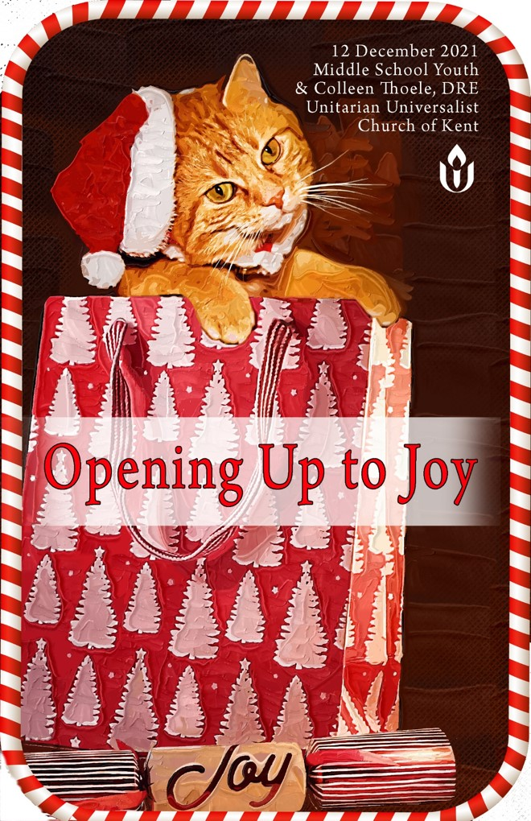
Opening Up to Joy

Order of Service December 12, 2021

“Sometimes your joy is the source of your smile, but sometimes your smile can be the source of your joy.”
― Thich Nhat Hanh

Gathering

Music for Gathering

Welcome Silas Thoele

Chime

Prelude Joy to the World, traditional
Colemann Packer accompanied by Wendy Mann

Words of Gathering Abby Kuras
Video Ode to Joy Flash Mob

Chalice Lighting Brady Kuras and Silas Thoele

We light this chalice because we are Unitarian Universalists
This is the church of the open mind
This is the church of the helping hands
This is the church of the loving heart
This is the church that takes care of the Earth and each other

Opening Hymn #100 I’ve Got Peace like a River

Holding One Another in Care and Compassion Colleen Thoele
Director of Religious Education

A time of silence, sharing our sorrows and losses, pastoral prayer,
and sharing our joys, wonder and awe.

Music Meditation Glimpse of Winter
by Tyler S. Grant
Raylynn Rome accompanied by Shirley Kiernan

Reflecting

Time for All Ages The Joy of Kittens
Raylynn Rome

1st Reading Laughter
author unknown
Brady Kuras

Laughter Meditation Silas Thoele

Reflection Hymn #311 Let it Be a Dance

Message Colemann Packer

Returning

Offering/Offertory I See the Light
Mandy Moore and Zachary Levi
Abby Kuras

Extinguishing the Chalice

We extinguish this flame, but not the light of truth, the warmth of community, or the fire of commitment. May we carry these in our hearts and minds until we are together again.

Closing Hymn #118 This Little Light of Mine
Benediction Raylynn Rome
Song of Blessing and Sending Go On Your Way in Peace
by Hal Walker
Golden Tones Junior Choir

Virtual Coffee Hour

Next Sunday, December 19, 2021
Celebrating Christmas: A Decade of Stories and Joy!
Led DRE Colleen Thoele and Sandy Eaglen and
with performances by the children of our community.
VISITORS - Welcome! We are glad you are here. Thank you for participating in worship with us today. We hope that you will find a spiritual home here and that you will be enriched in the liberal religious practice and heritage of Unitarian Universalism. This congregation is a member of the Unitarian Universalist Association. The members of this church take pride in the fact that we embrace people of all races, ethnicities, ages, creeds, sexual orientations, and abilities. In addition, we are a “Welcoming Congregation,” which means that we have taken part in a special program, designed by the UUA, for congregations that see a need to become more inclusive towards bisexual, gay, lesbian, and/or transgender people. The principles and purposes of the UUA, which we “covenant to affirm and promote,” can be found in the front of the hymnal, on the UUA website (www.uua.org), and on bookmarks available in the front entryway.
We are concerned for everyone’s safety. If we need to evacuate the building for a fire, a drill or for any other reason, please follow the directions of the worship leader. Parents and guardians should look for their children on the grassy area behind the Annex and should not go to the classrooms. People with mobility concerns or other special needs should proceed to the entryway where evacuation assistance will be available.

OUR SUNDAY SERVICE is offered at 10 AM via Zoom. Visit kentuu.org for information to join the service.

Church Office: The church office is located in the Eldredge Annex
(yellow house) next to the church building.
Office hours are: Monday -Friday 10 a.m. – 4:00 p.m.
Visit our website.

Church Address: Unitarian Universalist Church of Kent
228 Gougler Avenue, Kent, OH 44240.

Office – 330.673.4247 Fax – 330.677.4772
Email – churchoffice@kentuu.org
On the web – https://kentuu.org
Facebook - www.facebook.com/uuchurchofkent

CHURCH STAFF
Minister | Rev. Steven Protzman | revsteven@kentuu.org
Music Director | Hal Walker | halwalker@mac.com
Interim Music Manager | Vanessa Vesely
Dir. of Religious Education | Colleen Thoele | colleen@kentuu.org
Congregational Administrator | MaryBeth Hannan | churchoffice@kentuu.org
Nursery Staff | Michelle Bores
Sexton | Brian Mulloy | sexton@kentuu.org
Affiliated Community Minister | Rev. Renee Ruchotzke | rruchotzke@uua.org
Affiliated Community Minister, CLM | Rev. Christie Anderson
Commissioned Lay Minister (CLM) | Lori Mirkin-McGee
Commissioned Lay Minister (CLM) | Kathy Kerns

BOARD OF TRUSTEES 2021 – 2022
Board Moderator | Don Gregg
Board Asst. Moderator | Vivien Sandlund
Board Co-Secretary | Diane Kloss
Board Co-Secretary | Carol Weigand
Trustee | Liz Bright
Trustee | Rod Thompson
Trustee | Heidi Shaffer Bish

#100 I’ve Got Peace Like a River

I’ve got peace like a river,
I’ve got peace like a river,
I’ve got peace like a river in my soul. (2x)
I’ve got joy like a fountain…
I’ve got love like an ocean…
I’ve got pain like an arrow…
I’ve got tears like the raindrops …
I’ve got strength like a mountain …

#311 Let it Be a Dance

(Chorus)
Let it be a dance we do.
May I have this dance with you?
Through the good times and the bad times, too,
let it be a dance.

Let a dancing song be heard.
Play the music, say the words,
and fill the sky with sailing birds.
Let it be a dance.
Let it be a dance. Let it be a dance.
Learn to follow, learn to lead,
feel the rhythm, fill the need
to reap the harvest, plant the seed.
Let it be a dance.

(Chorus)

Everybody turn and spin,
let your body learn to bend,
and, like a willow with the wind,
let it be a dance.
Let it be a dance. Let it be a dance.
A child is born, the old must die;
a time for joy, a time to cry.
Take it as it passes by.
Let it be a dance.

(Chorus)

Morning star comes out at night,
without the dark there is no light.
If nothing’s wrong, then nothing’s right.
Let it be a dance.
Let it be a dance. Let it be a dance.
Let the sun shine, let it rain;
share the laughter, bear* the pain,
and round and round we go again.
Let it be a dance.

#118 This Little Light of Mine

This little light of mine, I’m gonna let it shine.
This little light of mine, I’m gonna let it shine.
This little light of mine, I’m gonna let it shine.
Let it shine, let it shine, let it shine.

Ev’rywhere I go, I’m gonna let it shine…

Building up a world, I’m gonna let it shine…

