Name(s) _______________________________________________

Address ______________________________________________________

City _____________________________ State ______ Zip _____________

Email _________________________________________________________

Phone ________________________________________________________

Examples of various giving levels:

|  |  |  |  |  |  |  |
| --- | --- | --- | --- | --- | --- | --- |
| Annual Amount | Monthly Amount | Weekly Amount |  | Annual Amount | Monthly Amount | Weekly Amount |
| $500 | $41.67 | $9.62 |  | $2,500 | $208.33 | $48.07 |
| $1,000 | $83.33 | $19.23 |  | $3,000 | $250.00 | $57.69 |
| $1,500 | $125.00 | $28.85 |  | $4,000 | $333.33 | $76.92 |
| $2,000 | $166.67 | $38.46 |  | $5,000 | $416.67 | $96.15 |

**I/We pledge $ ________________ in support of the Unitarian Universalist Church of Kent Mission and ministries for fiscal year 2024 (July 1, 2023 – June 30, 2024).**

Can your name be published to thank you for your pledge? ($ amount will NOT be listed) 🔾 Yes 🔾 No

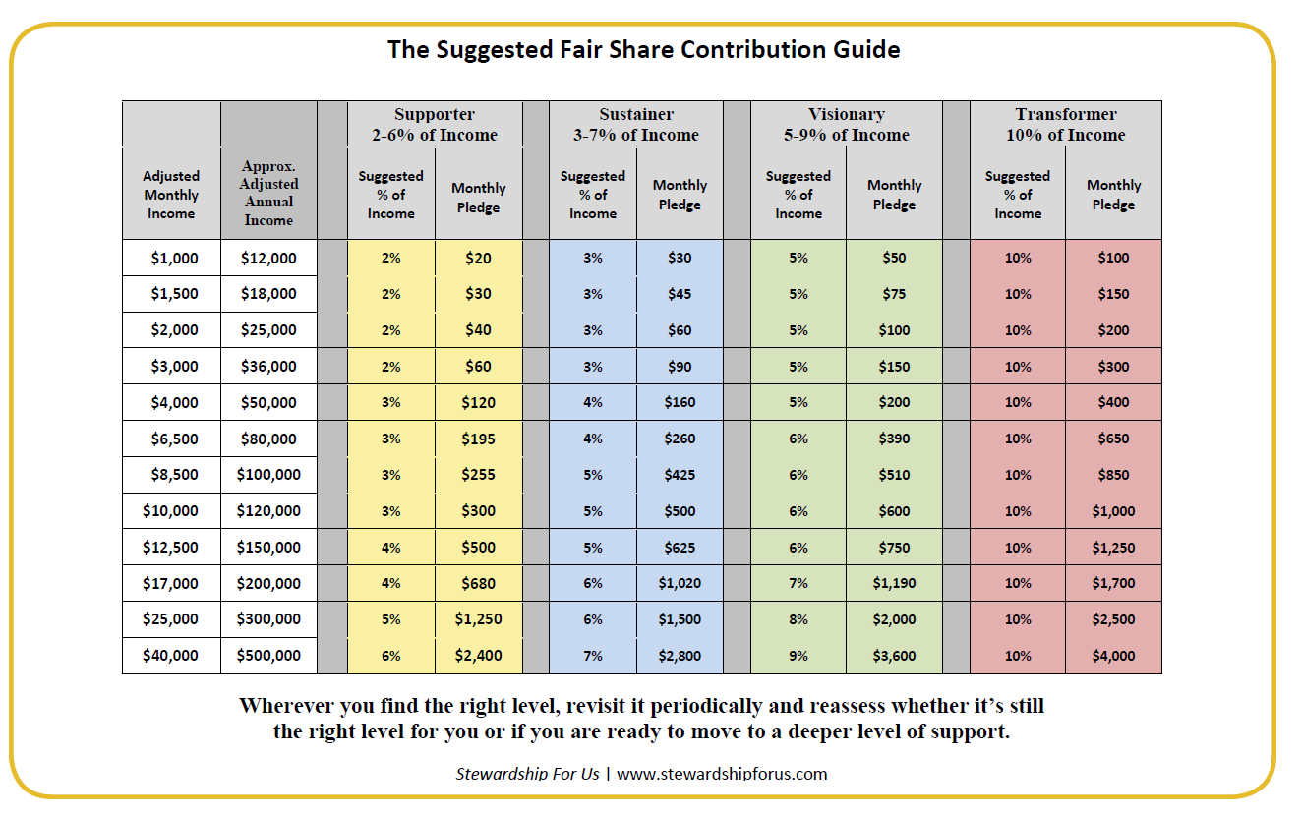

Name(s) _______________________________________________

Address ______________________________________________________

City _____________________________ State ______ Zip _____________

Email _________________________________________________________

Phone ________________________________________________________

Examples of various giving levels:

|  |  |  |  |  |  |  |
| --- | --- | --- | --- | --- | --- | --- |
| Annual Amount | Monthly Amount | Weekly Amount |  | Annual Amount | Monthly Amount | Weekly Amount |
| $500 | $41.67 | $9.62 |  | $2,500 | $208.33 | $48.07 |
| $1,000 | $83.33 | $19.23 |  | $3,000 | $250.00 | $57.69 |
| $1,500 | $125.00 | $28.85 |  | $4,000 | $333.33 | $76.92 |
| $2,000 | $166.67 | $38.46 |  | $5,000 | $416.67 | $96.15 |

**I/We pledge $ ________________ in support of the Unitarian Universalist Church of Kent Mission and ministries for fiscal year 2024 (July 1, 2023 – June 30, 2024).**

Can your name be published to thank you for your pledge? ($ amount will NOT be listed) 🔾 Yes 🔾 No

_________________________________________